Class Outline: Animal Defenses on the Sandy Beach
Grade: 1st
Developed By: Zoe Allen

Question: How do animals in the sandy beach protect themselves?
(As class starts, have students take a sheet of paper and fold it in half. Half for questions/observations. Half for drawing.)

7: Welcome and introduce sandy beach
- What is the sandy beach?
  - Video: waves on the beach
  - Take a moment to observe: What do you observe about the sandy beach?
    - Habitat, waves, sand
- What is sand made of?
  - Take a minute to discuss with your class
    - Rocks, shells, glass, coral eroded away by the waves
- Review of tides
  - What do you notice in these two pictures? Is this the same beach?
    - The same beach, 6 hours apart
    - The tides are caused by the gravitational pull of the Earth and Moon
- What challenges do animals face on the sandy beach?
  - Waves, predators, people, and much more

5: Students meet with teacher and compile questions
- What kinds of animals live in the sand? How do they survive?
- What are some adaptations that help them survive in their habitat?

7: Adaptations animals use to protect themselves
- What is an adaptation?
  - A characteristic or behavior that helps an animal survive in its habitat
  - Examples: Humans have thumbs to hold things, cats and dogs have fur to keep them warm, birds have wings to help them fly.
- Example: Sand crab (AKA mole crab)
- How do sand crabs survive on the beach?
- Video: Sand crab burying itself https://www.pbs.org/wnet/nature/blog/pacific-mole-crabs-deep-look/
  - Bury themselves in the sand
- Video: Sand crab feeding https://youtu.be/XdL78W22Ywo
- Do it do it: Become a sand crab
  - Twist in your seat to dig into the sand
  - Make your arms into antennae and wave them around to catch food
  - Lick the food off your antennae and repeat

5: Students meet with teacher and compile questions
- Have you ever been knocked down by a wave at the beach? How can you stop yourself from being knocked down?
- What are some ways animals can stop themselves from being knocked over by waves?

7: Adaptations animals use to protect themselves
- How might an animal in the sand protect itself from the waves?
- Example: Sand dollar
- Draw with me: Sand dollar
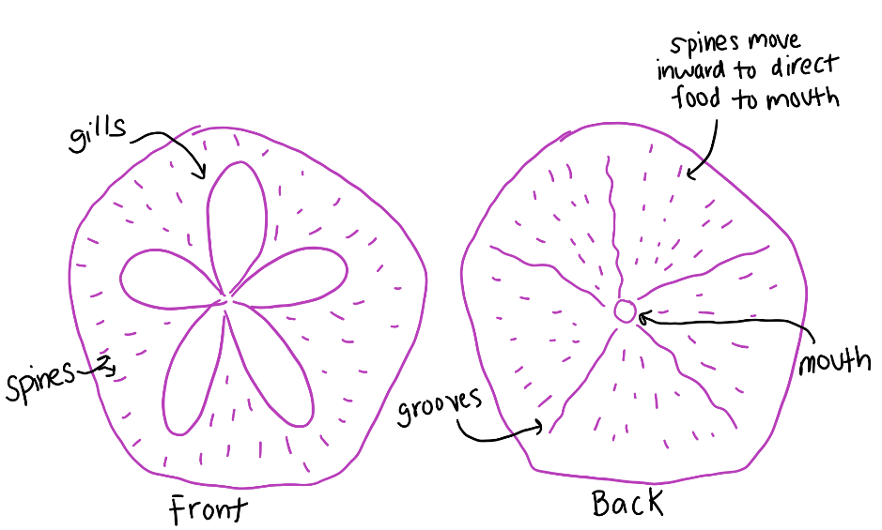

  - Students draw along with teacher while teacher uses whiteboard
- Video: sand dollar bed https://www.youtube.com/watch?v=mvdFPvoBvmo&feature=youtu.be
  - What do you observe the sand dollars doing?
- How do sand dollars stay in the sand?
  - Take a minute to talk to your class: How do you think the sand dollars stay in the sand?
    - Eat a little bit of sand to weigh them down

5: Students meet with teacher and compile questions
- Do the animals that live in the sandy beach live on top or below the sand? What tools could you use to find these animals?
- How do humans affect the sandy beach habitat?

7: Finding these animals in their natural habitat
- How do humans affect the sandy beach habitat?
  - Pollution
  - Talk a minute to talk to your class: What are some ways we can all help the sandy beach?
    - Throw away trash
    - Recycle
    - Reduce amount of trash we produce
    - Use less plastic
- One of the ways we can help is by studying it- lets see how!
- What are some tools we could use to find these animals in the sand?
  - Shovel or hands for digging
  - Colander for shifting through sand
- Video: Sand crabbing and exploring the beach

5: Students meet with teacher and compile questions

