Class Outline: Animal and Plant Defenses on the Rocky Shore
Grade: 1st
Developed By: Zoe Allen

Question: How do plants and animals in the rocky shore protect themselves?
(As class starts, have students take a sheet of paper and fold it in half. Half for questions/observations. Half for drawing.)

7: Welcome and introduce the rocky shore
- What is the rocky shore?
  - Video: waves hitting the rocky shore.
  - Take a moment to make observations: What do you observe about the rocky shore?
    - Habitat, rocks, waves, water, pools
- What causes tides?
  - Pools are left behind when the tide is low
  - The gravitational pull from the Earth and Moon causes the tides
- What challenges do animals face on the rocky shore?
  - Waves, exposure to sun, exposure to air, predators, and many more

5: Students meet with teacher and compile questions
- What is an adaptation? What is an adaptation that humans have?
- What adaptations would be good for living in a tidepool?

7: Adaptations animals use to protect themselves
- What is an adaptation?
  - A characteristic or behavior that helps an animal survive in its habitat
  - Examples: Humans have thumbs to hold things, cats and dogs have fur to keep them warm, birds have wings to help them fly.
- Example: Sea star
- Video: tube feet https://www.youtube.com/watch?v=FJBNW4BYpy4&feature=youtu.be
- How do tube feet help protect them?
  - Take a minute to talk to your class: How do you think tube feet protect sea stars?
    - Tube feet stick to rocks so they do not get swept away by waves
    - Tube feet grab onto food
  - Do it do it: Become a sea star
    - Grow 5 sea star arms using arms, legs, and head
    - Grow tube feet all over arms
    - Move around the rocks in search of a tasty mussel to eat
    - Grab onto the mussel with your sticky tube feet
    - Pry open the mussel shell and stick your stomach inside the shell
    - Digest the mussel outside of your body!
    - Bring your stomach back in your body
5: Students meet with teacher and compile questions
- Do you think some animals are better adapted for living in the tidepools than others? If you were an animal in the tidepools, what adaptation would you want?

7: Adaptations animals use to protect themselves
- Example: Sea urchin
- Video: sea urchin https://www.youtube.com/watch?v=MZTt7wy0etg&feature=youtu.be
- Take a minute to talk to your class: How do you think a sea urchin protects itself?
- Draw with me: sea urchin spines, tube feet, pedicellariae

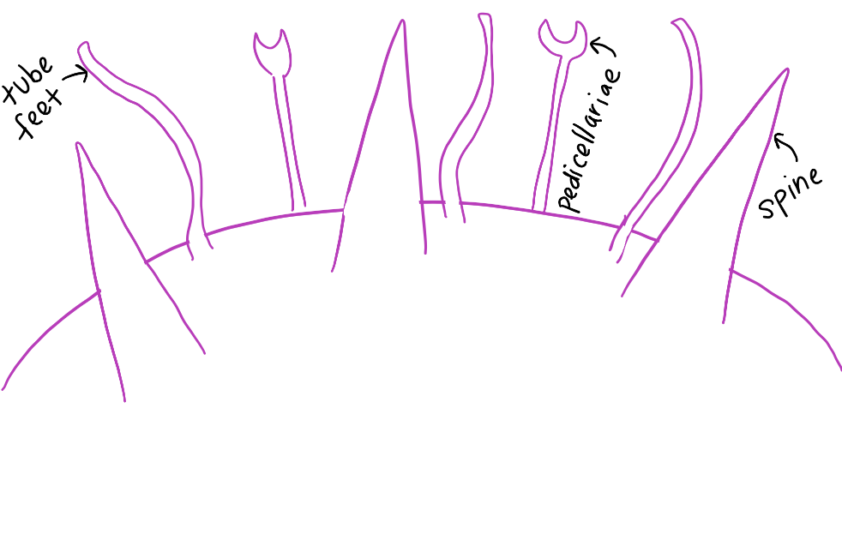
  - Students draw along with teacher while teacher uses the white board
  - How do all of these adaptations help protect them?/What do they use them for?
    - Spines: Protect them from predators
    - Tube feet: Stick onto rocks and prey
    - Pedicellariae: Break off pieces of food
- Example: sea snail
- How does a sea snail protect itself?
  - Shell: Can tuck inside of shell
  - Operculum: “trap door” closes up to protect snail on the inside

5: Students meet with teacher and compile questions
- Do you think there are plants in the ocean? How are they different from plants on land?
- How could a plant protect itself in the ocean?

7: Adaptations plants use to protect themselves
- Are there plants in the ocean?
  - Seaweed (AKA algae)
- Example: Giant kelp
- How is kelp protected from the waves?
- Draw with me: kelp holdfast, stipe, blade, pneumatocyst
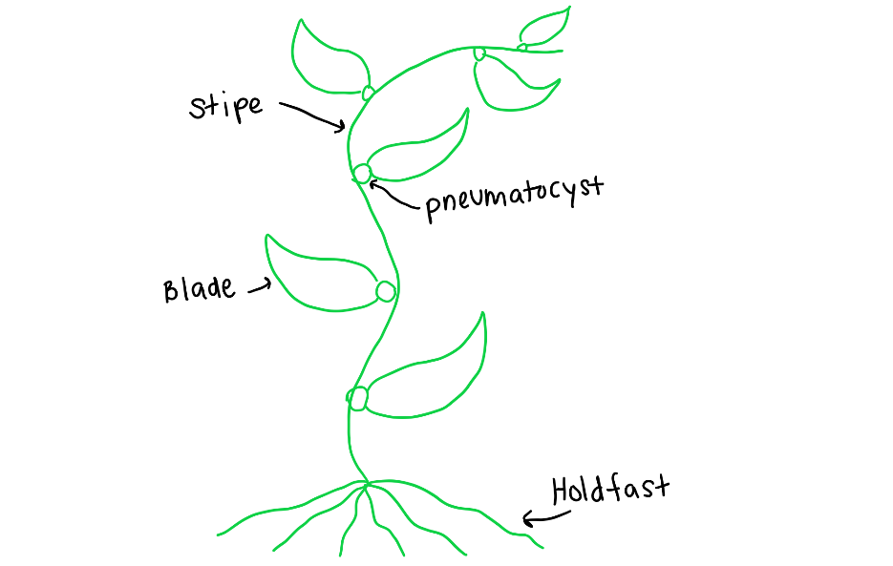

  - Students draw along with teacher while teacher uses white board
    - Holdfast: Anchors kelp to the bottom
    - Stipe: Like a plant stem, it keeps the kelp upright
    - Blade: Like a leaf, where most of the photosynthesis occurs
    - Pneumatocyst: “air bladder” keeps the kelp floating towards the surface so it can sunlight for photosynthesis
- Do it do it: Become kelp
  - Make a rock with your fist
  - With other hand, make a holdfast and grab onto rock
  - Use arm to grow your kelp upwards
  - Sway kelp in the ocean current, getting stronger and stronger, and then calm again

5: Students meet with teacher and compile questions

